Height of an Oblique Circular Cylinder
# Source: AI Source: Provided by: [Data Path: Persons Table -> ID Column: 1, Name_En Column: Motasem Essam] -> From: [ChatGPT] on [7/25/2026]
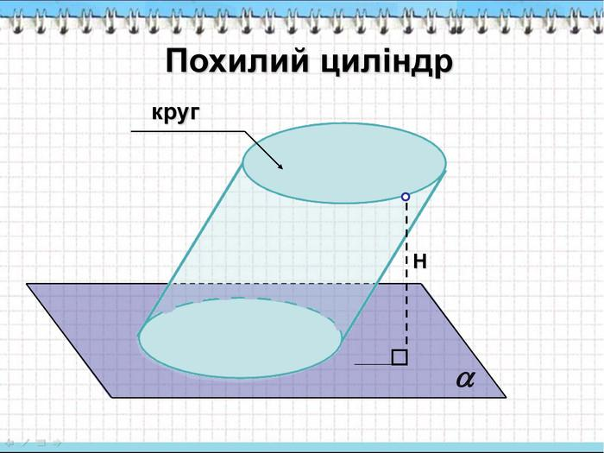
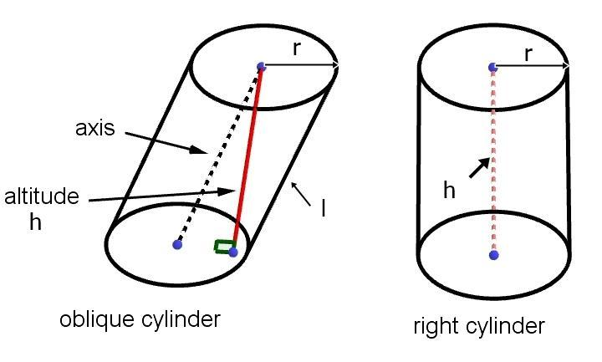
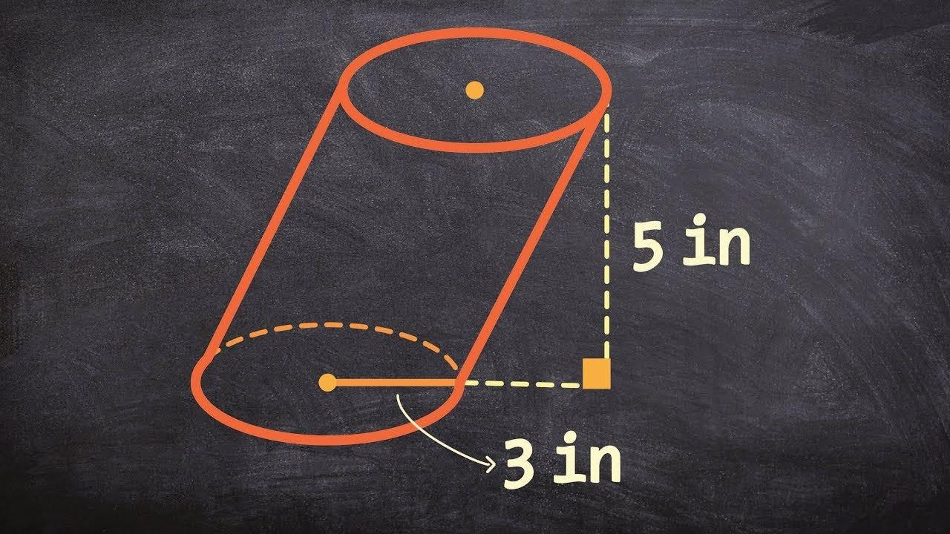

Definition
# Source: AI Source: Provided by: [Data Path: Persons Table -> ID Column: 1, Name_En Column: Motasem Essam] -> From: [ChatGPT] on [7/25/2026]
The height of an oblique circular cylinder is the perpendicular distance between the planes containing its two parallel, congruent circular bases.
Unlike a right circular cylinder, an oblique circular cylinder has an axis that is inclined to the base planes. Therefore, its height is generally shorter than the length of its inclined axis.
- Common symbols: $h$ or $H$
- Base shape: Circle
- Base relationship: Parallel and congruent
- Height direction: Perpendicular to both base planes
- Axis direction: Inclined to the base planes

Simple Definition
# Source: AI Source: Provided by: [Data Path: Persons Table -> ID Column: 1, Name_En Column: Motasem Essam] -> From: [ChatGPT] on [7/25/2026]
The height of an oblique circular cylinder is the straight, perpendicular distance from one circular base's plane to the other base's plane—not the distance measured along the sloping side or axis.

Geometric Representation
# Source: AI Source: Provided by: [Data Path: Persons Table -> ID Column: 1, Name_En Column: Motasem Essam] -> From: [ChatGPT] on [7/25/2026]
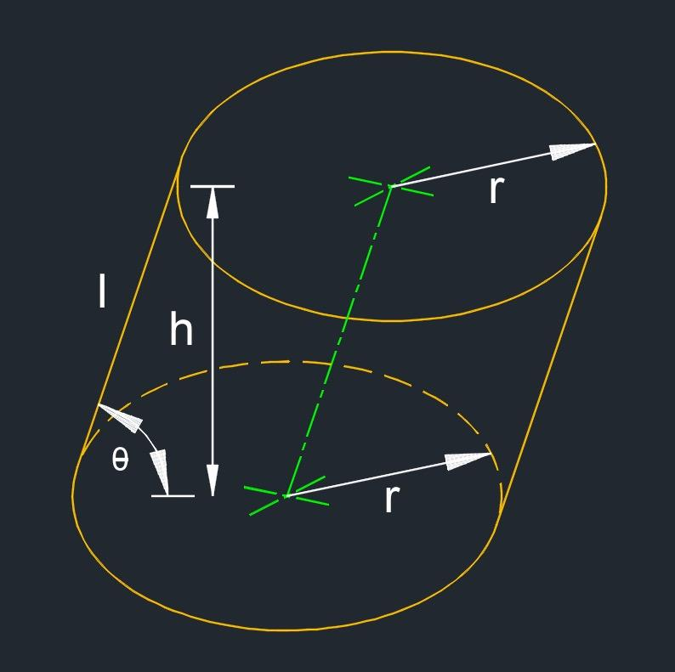
The principal measurements are:
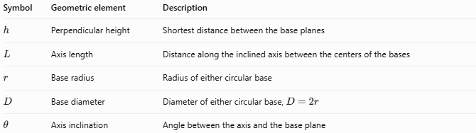
Symbol | Geometric element | Description
$$h$$ | Perpendicular height | Shortest distance between the base planes
$$L$$ | Axis length | Distance along the inclined axis between the centers of the bases
$$r$$ | Base radius | Radius of either circular base
$$D$$ | Base diameter | Diameter of either circular base, $D=2r$
$$θ$$ | Axis inclination | Angle between the axis and the base plane
For a genuinely oblique cylinder, the axis is inclined, so $L>h$.

Types and Related Measurements
# Source: AI Source: Provided by: [Data Path: Persons Table -> ID Column: 1, Name_En Column: Motasem Essam] -> From: [ChatGPT] on [7/25/2026]
The height of an oblique circular cylinder can be considered alongside other measurements:
- Perpendicular height: Distance measured normal to the base planes.
- Axis length: Length of the inclined segment joining the centers of the two bases.
- Lateral edge length: Length along a straight generator of the lateral surface; in a standard oblique circular cylinder, this is constant but generally differs from the perpendicular height.
- Vertical height: Sometimes used informally for perpendicular height, but “perpendicular height” is more precise.

Mathematical Formulas

Height from axis length and inclination
# Source: AI Source: Provided by: [Data Path: Persons Table -> ID Column: 1, Name_En Column: Motasem Essam] -> From: [ChatGPT] on [7/25/2026]
When $θ$ is the angle between the inclined axis and the base plane:
$$\boxed{h=L\sin{θ}}$$
where $L$ is the axis length.
If $α$ is instead the angle between the axis and the perpendicular to the base plane:
$$\boxed{h=L\cos{α}}$$
Since $θ+α={90}^{∘}$, these formulas are equivalent.

Height from volume and radius
# Source: AI Source: Provided by: [Data Path: Persons Table -> ID Column: 1, Name_En Column: Motasem Essam] -> From: [ChatGPT] on [7/25/2026]
The volume of an oblique circular cylinder is:
$$V=πr^{2}h$$
Therefore:
$$\boxed{h=\frac{V}{πr^{2}}}$$
Using the base diameter $D=2r$:
$$\boxed{h=\frac{4V}{πD^{2}}}$$
Important: The volume formula uses perpendicular height, not the inclined axis length.

Height from volume and base area
# Source: AI Source: Provided by: [Data Path: Persons Table -> ID Column: 1, Name_En Column: Motasem Essam] -> From: [ChatGPT] on [7/25/2026]
If $A_{b}$ is the area of a circular base:
$$V=A_{b}h$$
Therefore:
$$\boxed{h=\frac{V}{A_{b}}}$$
where $A_{b}=πr^{2}$.

Worked Examples
# Source: AI Source: Provided by: [Data Path: Persons Table -> ID Column: 1, Name_En Column: Motasem Essam] -> From: [ChatGPT] on [7/25/2026]
Example 1 — Calculate height from axis length
An oblique circular cylinder has an axis length of $12\text{ cm}$, inclined at ${30}^{∘}$ to its base plane. Find its perpendicular height.
Solution:
$$h=L\sin{θ}$$
$$h=12{\sin{30}}^{∘}$$
$$h=12\left(0.5\right)$$
$$\boxed{h=6\text{ cm}}$$
Example 2 — Calculate height from volume
A cylinder has a volume of $150π{\text{ cm}}^{3}$ and a base radius of $5\text{ cm}$. Find its perpendicular height.
Solution:
$$h=\frac{V}{πr^{2}}$$
$$h=\frac{150π}{π{\left(5\right)}^{2}}=\frac{150}{25}$$
$$\boxed{h=6\text{ cm}}$$
Example 3 — Calculate height from diameter
An oblique circular cylinder has a volume of $96π{\text{ m}}^{3}$ and a base diameter of $4\text{ m}$. Find its perpendicular height.
Solution:
$$h=\frac{4V}{πD^{2}}$$
$$h=\frac{4\left(96π\right)}{π{\left(4\right)}^{2}}=\frac{384}{16}$$
$$\boxed{h=24\text{ m}}$$

Comparison with Related Concepts
# Source: AI Source: Provided by: [Data Path: Persons Table -> ID Column: 1, Name_En Column: Motasem Essam] -> From: [ChatGPT] on [7/25/2026]
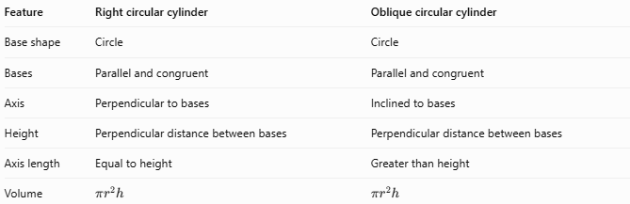
Feature | Right circular cylinder | Oblique circular cylinder
Base shape | Circle | Circle
Bases | Parallel and congruent | Parallel and congruent
Axis | Perpendicular to bases | Inclined to bases
Height | Perpendicular distance between bases | Perpendicular distance between bases
Axis length | Equal to height | Greater than height
Volume | $$πr^{2}h$$ | $$πr^{2}h$$
The key distinction is that height always means perpendicular distance between the base planes, regardless of whether the cylinder is right or oblique.

Surface Area Considerations
# Source: AI Source: Provided by: [Data Path: Persons Table -> ID Column: 1, Name_En Column: Motasem Essam] -> From: [ChatGPT] on [7/25/2026]
The perpendicular height is essential for calculating volume, but it should not automatically be substituted for every length in a surface-area calculation.
For a right circular cylinder, the lateral surface area is:
$$S_{L}=2πrh$$
For an oblique circular cylinder, this formula does not generally apply when $h$ is the perpendicular height. The lateral surface area depends on the slant geometry of the cylinder.

Applications
# Source: AI Source: Provided by: [Data Path: Persons Table -> ID Column: 1, Name_En Column: Motasem Essam] -> From: [ChatGPT] on [7/25/2026]
The perpendicular height of an oblique circular cylinder is useful in:
- Calculating the capacity of inclined cylindrical containers.
- Determining the volume of slanted cylindrical components.
- Measuring the separation between parallel circular faces in mechanical parts.
- Solving solid-geometry problems involving inclined axes.
- Calculating material volume in cylindrical engineering structures.

Key Points
# Source: AI Source: Provided by: [Data Path: Persons Table -> ID Column: 1, Name_En Column: Motasem Essam] -> From: [ChatGPT] on [7/25/2026]
- The height is the perpendicular distance between the two base planes.
- The axis is inclined rather than perpendicular to the bases.
- For an oblique cylinder, axis length and perpendicular height are generally different.
- If the axis length is $L$ and its angle to the base plane is $θ$, then $h=L\sin{θ}$.
- The volume is $V=πr^{2}h$, using perpendicular height.
- Surface-area calculations require attention to the cylinder's inclined geometry.

Conclusion
# Source: AI Source: Provided by: [Data Path: Persons Table -> ID Column: 1, Name_En Column: Motasem Essam] -> From: [ChatGPT] on [7/25/2026]
The height of an oblique circular cylinder measures the perpendicular separation between its parallel circular bases. It is distinct from the inclined axis length, and correctly identifying it is essential for accurate volume calculations and solid-geometry problem solving.

